

COURSE MAINTENANCE 1059


RAKES IN BUNKERS? YES OR NO?
Dennis Divot
Secretary At Work: August 2011 …revised July 2016

Whilst watching the British Ladies Open Golf Championship from Royal Birkdale, I became somewhat irritated by Peter Alliss’s daily diatribe about rakes not being in bunkers and his questioning of who had given the Club that advice? I quote from the Current Decisions on the Rules of Golf, (2016-2017) P553.

Misc./2 Whether Rakes Should Be Placed In or Outside Bunkers.
Q: Should rakes be placed in or outside bunkers?
A: There is not a perfect answer for the position of rakes, but on balance it is felt there is less likelihood of an advantage or disadvantage to the player if rakes are placed outside of bunkers. It may be argued that there is more likelihood of a ball being deflected into or kept out of a bunker if the rake is placed outside the bunker. It could also be argued that if the rake is in the bunker it is most unlikely that the ball will be deflected out of the bunker.

However, in practice, players who leave rakes in bunkers frequently leave them at the side which tends to stop a ball rolling into the flat part of the bunker, resulting in a much more difficult shot than would otherwise have been the case. This is most prevalent at a course where the bunkers are small. When the ball comes to rest on or against a rake in the bunker and the player must proceed under Rule 24-1, it may not be possible to replace the ball on the same spot or find a spot in the bunker which is not nearer the hole — see Decision 20-3d/2.

If rakes are left in the middle of the bunker, the only way to position them is to throw them into the bunker and this causes damage to the surface. Also, if a rake is in the middle of a large bunker, it is either not used or the player is obliged to rake a large area of the bunker, resulting in unnecessary delay.

Therefore, after considering all these aspects, it is recommended that rakes should be left outside bunkers in areas where they are least likely to affect the movement of the ball.

Ultimately, it is a matter for the Committee to decide where it wishes rakes to be placed.
(The italics are my additions.)

In making such a decision the Committee need to take into account the nature and design of the bunkers on their course. On links courses, most bunkers are designed to collect balls running into a particular area, swale or depression. On the harder surface of a links course the ball may run in from any angle, but the front revetting and steep sides generally throw the ball towards the centre of the bunker. Where there are steps leading into the bunker it is logical for the rake to be left there.

Photograph A
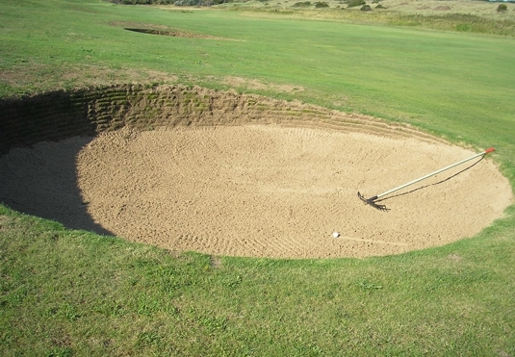
Photograph A shows a typical Links bunker (Courtesy of Burnham & Berrow Golf Club). The photograph was taken in actual play. Their policy is to place the rake prongs in the bunker with the handle end just outside. This ensures that the rake head is about 5 or 6 feet into the bunker, and if it were to stop the ball as it runs in, on removal of the rake, the player would have a fair shot.
√

Contrast this with a typical parkland bunker, where the base of the bunker is likely to be only just below ground level to facilitate artificial drainage and gives the bunker a much shallower lip. The thicker softer grass around the bunker may tend to slow down a running ball down before it goes in. If it pitches directly into the bunker it may well finish close to the front edge. There is a much higher probability of the ball being close to the bunker edge than there is in a links type. The most frustrating situation occurs when the rake has been placed, prongs down, about 4 inches into the bunker with the handle outside. The ball may become trapped on the down slope between the edge of the bunker and the rake. Under the “definitions” section of the Rules, the rake is a movable obstruction and Rule 24-1-a applies. The position of the ball should be marked so that the ball may be replaced if it moves after removal of the rake. Through someone else’s thoughtlessness the player is then left with a very difficult shot close to the lip of the bunker. If the sand is hard-packed or wet and the ball rolls closer to the hole when placed, the “Decision on the Rules: 20-3d/2” applies and the player must take a one shot penalty and drop the ball outside the bunker.

Photograph B
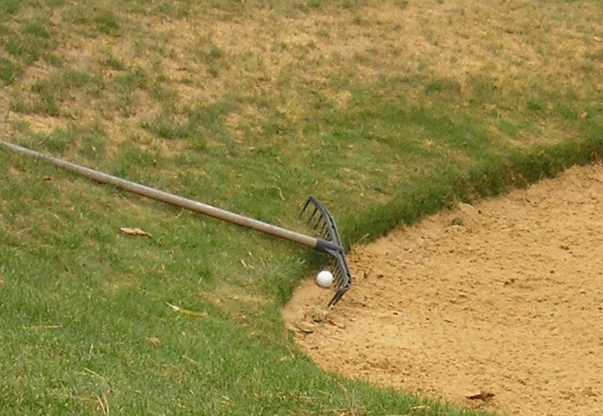
Photograph B shows how the above situations can occur. (Courtesy of Enmore Park Golf Club) The position of the rake was not staged; it had been left in exactly that position by someone in normal play. The ball, however, had been placed deliberately to illustrate the unfairness of leaving the rake with the prongs just inside the bunker.
X

Rakes are available with a small built-in stand. Some Clubs have double or single metal stands to lift all or part of the rake up above ground level, but these are an inconvenience to the greenstaff when mowing around the bunker and disappointingly, are not always the recipients of the rake after use. If the single type stand is used, then the rake handle should be in the bunker with the prongs supported by the stand. That way, there is virtually no chance of the rake interfering with the lie of the ball.

Photograph C
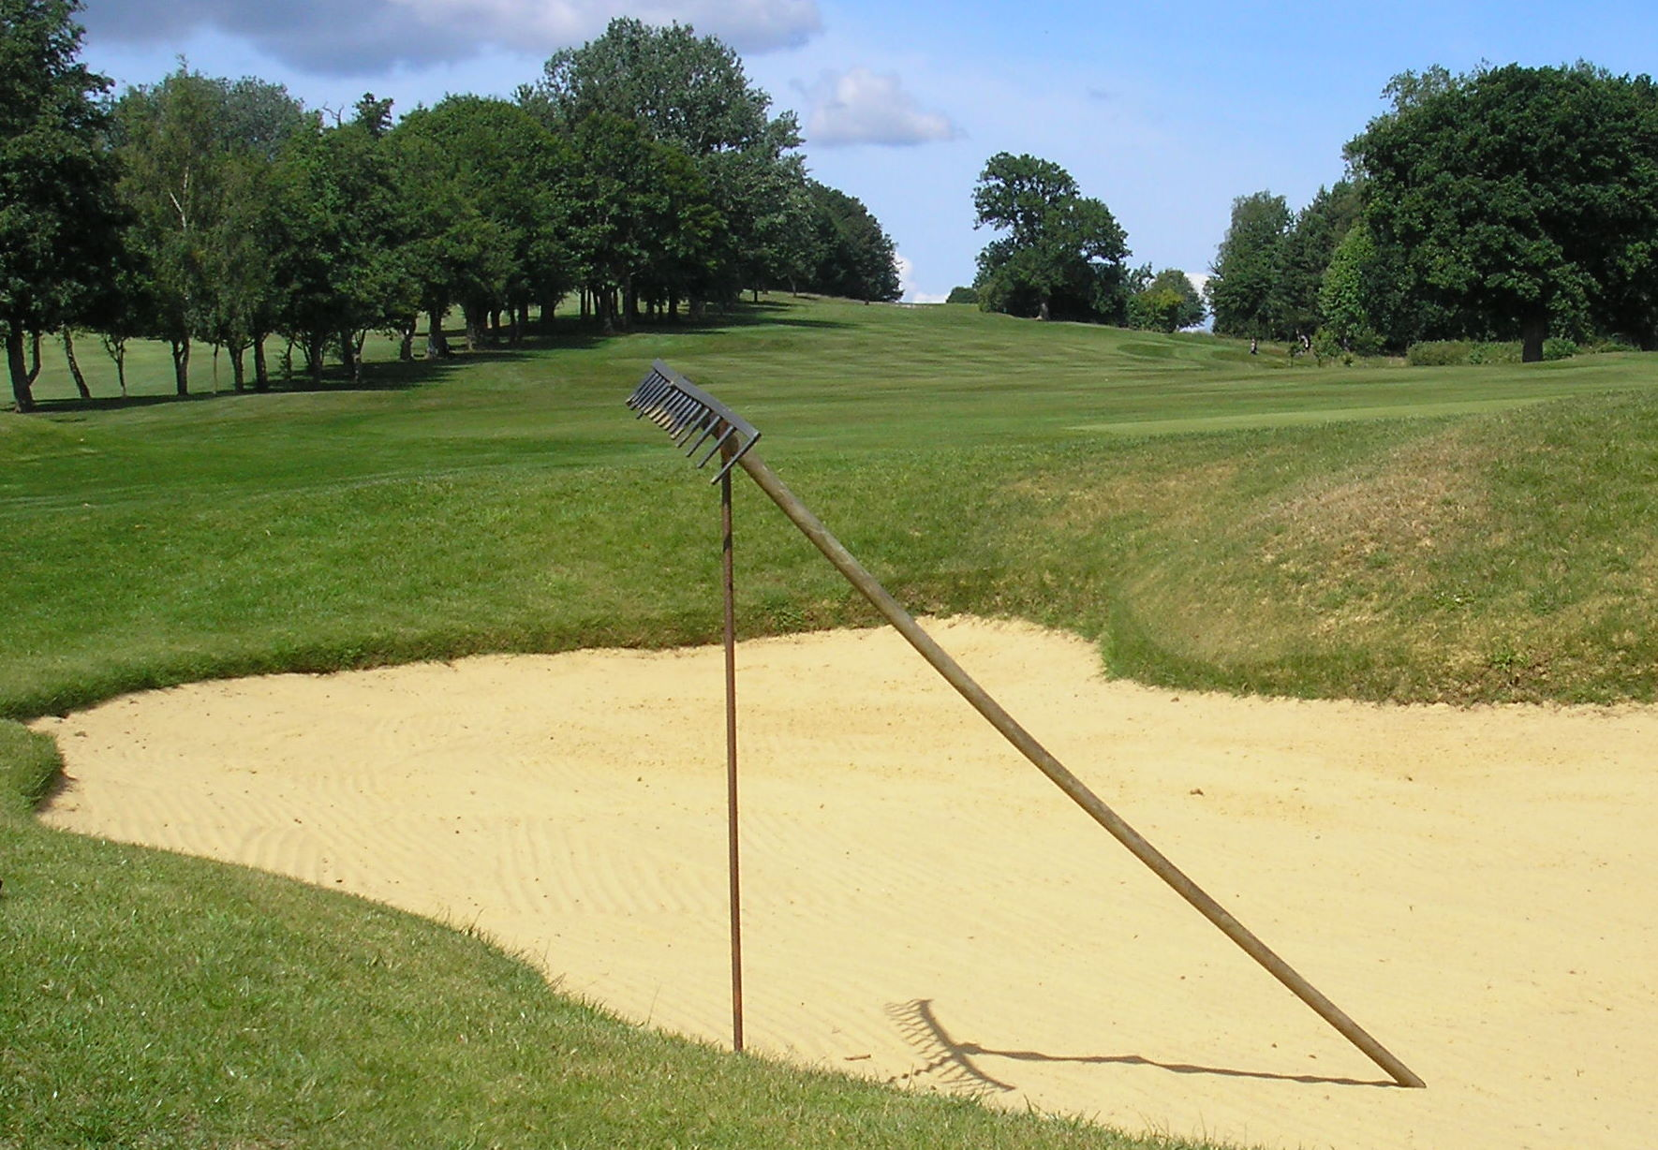
See photographs C and D. Sinking tubes in the ground to hold the rake vertical, appears to be a neat option, but golfers cannot be bothered to find the hole and after a short time they fall out of use. I was taught that on parkland courses, rakes should be placed (not thrown) on the outside the bunker, a yard or so from the edge, on a banked side. Preferably in a place where they were unlikely to prevent a ball going into the bunker with their prongs facing upwards, to reduce the possibility of their being broken off. However, on a links course, all of the rake should be in the bunker prongs down, having been placed at arms length back in the bunker after raking.
√

Photograph D
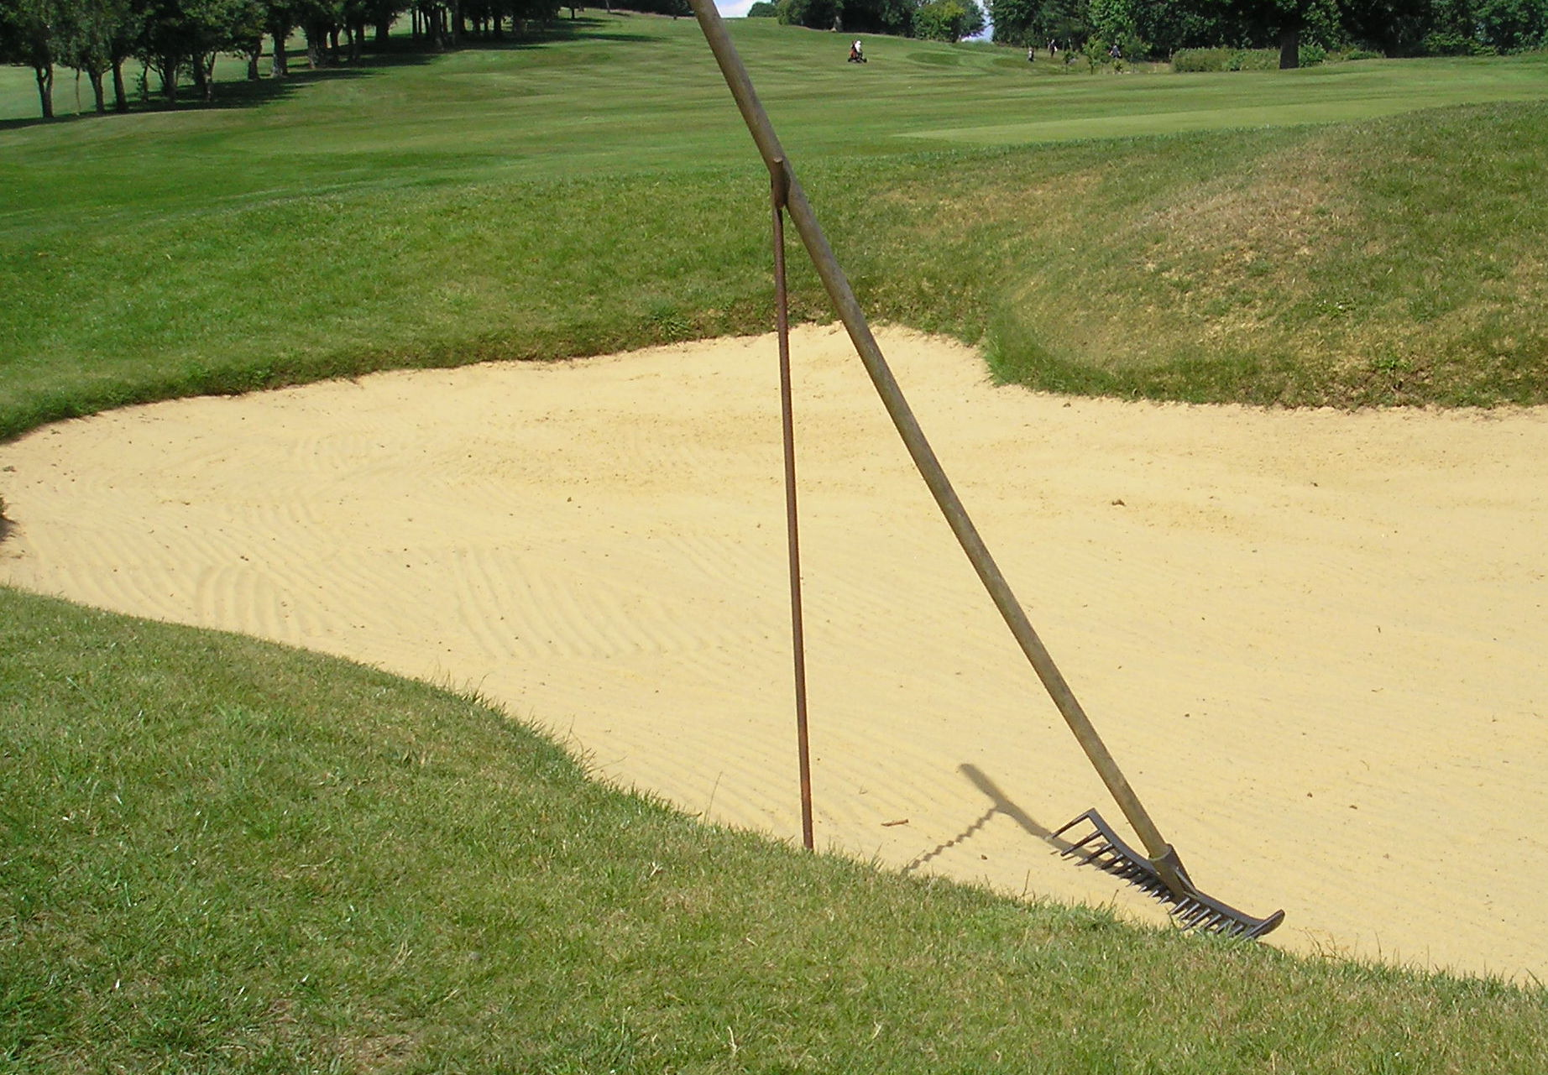
At the Amateur Championship at Hillside in June 2011, each rake was outside the bunker and at least 3 yards from the edge, in a position where it could not affect the likelihood of the ball going into the bunker.
X

The R&A accept there is a difference of opinion on the issue but designate the Club Committee to discuss and determine policy. Perhaps it is too much to hope that it will become standard procedure to place rakes outside the bunker in accordance with the R&A recommendation except for those Clubs that have decided there are overwhelming local factors for rakes to be placed in the bunkers. It would be useful if the Club policy on rakes was included as an addendum to the Local Rules on the card, so that members and visitors are aware of the protocol, and hopefully, achieve consistency of rake positioning all round the course. Whatever the decision please can we see an end to rakes being left with their prongs just in the bunker and the bulk of their handle length outside?

The author wishes to thank Shona McRae of the R&A for checking the accuracy of all references to the R&A Rules.

[This document is prepared for guidance and is accurate at the date of publication only. The GCMA will not accept any liability (in negligence or otherwise) arising from any member or third party acting, or refraining from acting, on the information contained in this document.]

