
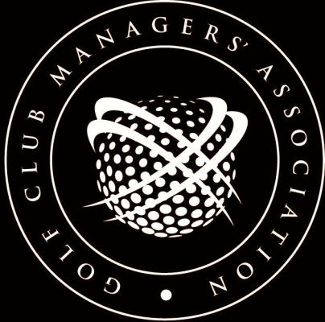
EMPLOYMENT 3028


JOB DESCRIPTION:
CHEF/COOK
(reviewed February 2016)

Job Title
Chef/Cook

Main Purpose of Job
To provide a food service as required by the ............................................ golf club. This will consist of table meals in the dining room and snacks for the bar areas.

Job Location
The clubhouse of the ................................................... golf club and any other area designated by the club. (This might include areas such as tents or other items for special events).

Responsibilities
To provide a catering service as laid down by the committee (proprietor). To control the catering staff employed in both the kitchen, dining room and bar and see that the service provided is of the required standard. You will produce daily menus of food available both in the dining room and the bar areas within the guidelines set by the club.

Duties
Apart from preparing the food you will be responsible for ordering supplies and checking all vouchers against accounts. You will also be responsible in seeing that the staff employed as waiters/esses not only carry out their jobs in an efficient manner but also see that all cash collected is properly recorded on the tills and handed over to the club office on a daily basis. Money collected after office hours must be recorded and bagged and given to the Bar Manager for safe keeping in the bar safe. You will be responsible to see that the kitchen, food preparation and storage areas are kept clean and tidy and also see that the club cleaners keep the dining room clean, reporting any failures to the Secretary/Manager.

Authority & Discretion
You will be responsible for engaging sufficient staff to see that an adequate service is provided. You will check all staff time sheets under your control and authorise their correctness before handing them over to the club office. You have the authority to purchase daily food requirements but all orders made must be recorded in the purchase book and signed by the person ordering. Any stock no longer in a fit condition to use must be disposed of and recorded in the disposal book and signed. Any serious losses in this respect must immediately be reported to the Secretary/Manager.

Liaison
You must at all times liaise with the bar manager and other clubhouse staff and with any club member designated by the committee to liaise with you. (This may be for social or other club events).

Conditions
You are responsible for seeing that all staff observe all hygiene and health & safety regulations with a particular emphasis on those concerned with the handling of food.

[This document is prepared for guidance and is accurate at the date of publication only. The GCMA will not accept any liability (in negligence or otherwise) arising from any member or third party acting, or refraining from acting, on the information contained in this document.]

