

GAME OF GOLF 1071


SCORECARDS: 2. COMPETITIVE GOLF
INDIVIDUAL STABLEFORD

David Weston, the former secretary of Enmore Park GC, writes the second in a series of the correct way to mark a scorecard - Competitive golf: Individual Stableford.
Secretary At Work: October 2011 (revised March 2016)

For the benefit of the PLAYER and those members of the Competitions Committee or Professional Staff who have to check that Cards in all types of competitions, it is important that they have been correctly marked and submitted. This sequence of illustrations has been devised to try to ensure that all Competitive Cards fulfil the requirements of the Rules of Golf.

In those Competitions where a computer is in use, the computer will total the Medal score, calculate the Stableford score or work out the Bogey/Par result.

The two most common errors are:
- Something other than, or in addition to, the GROSS SCORE is included in the box for the Player, or the gross score is absent.
- The Markers Gross score is not in the column provided, but is elsewhere on the Card.

The following 6 examples are given. For each there is an explanation sheet and an example of a card.
- Individual Medal (library doc: 1066)
- Individual Stableford (Ladies & Gents for differing Stroke indices)
- Individual Par/Bogey (library doc: 1078)
- Bowmaker (3-Ball Team) (library doc: 1084)
- Pro-Am 4-Ball Team (library doc: 1088)
- 4 Ball Better Ball Pairs (library doc: 1093)

Note There is no copyright on these illustrations. They may be copied, displayed or transmitted in written or electronic form.

[This document is prepared for guidance and is accurate at the date of publication only. The GCMA will not accept any liability (in negligence or otherwise) arising from any member or third party acting, or refraining from acting, on the information contained in this document.]
A significant number of cards are being received that are incorrectly marked. This is the second in a series of articles explaining the responsibilities of the committee and the player together with examples of correctly marked cards.

In this type of competition, each player is playing for points on each hole:

3 under par 5
2 under par 4
1 under par 3
Par 2
1 over par 1

The obligations of the committee (Rule 33) and the player (Rule 6) are exactly the same as they are for Medal golf. It is strictly the responsibility of the committee to work out the Stableford points. It is usual for both the marker and player to check the net points each can score before putting out.

Incorrectly marked cards which are received regularly contain both the gross and net scores in the player column A, or the gross score and the points.
4
3

The above is incorrect and may be taken as a score of 43 for the hole. No points would be given for a hole marked in this way.

Column A should contain only the gross score for the hole as in Medal play.

The marker’s gross score for each hole should be in column D.

Prior to starting the player should put a mark or cross at the side of each hole at which he/she is entitled to a stroke and 2 marks or crosses at each hole where there is an entitlement of 2 shots. Some players prefer to circle or double circle the square. This enables the marker to calculate the points for the hole and record it in the column provided.

If you cannot score a point on a hole, the player should pick up his/her ball. A Stableford round should be quicker than a medal round.

At the end of the round, the player should put the gross score for each hole into the computer. The computer is programmed to calculate the number of points scored for each hole, total them for the round and account for N/R on several holes for handicapping purposes. The player should check his/her points total against that on the computer before posting it in the correct box.

The following are examples of gents and ladies specimen cards. They are not the same because of the difference in the par and stroke index.
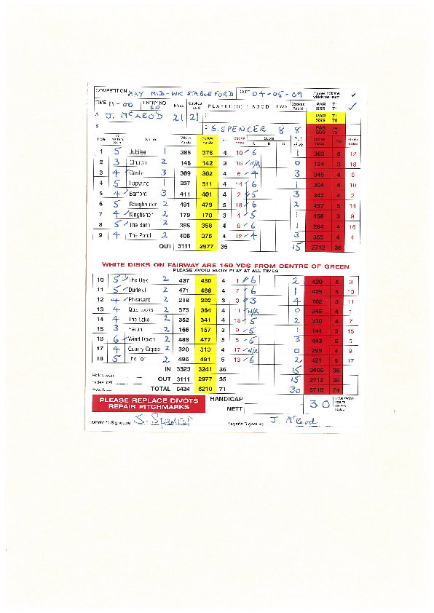

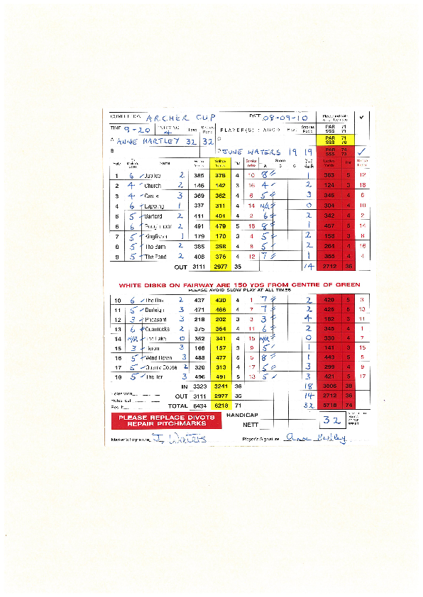

David Weston is the former secretary of Enmore Park GC.

