

GAME OF GOLF 1088


SCORECARDS: 5. COMPETITIVE GOLF
TEAM OF 4/PRO-AM/AM-AM

David Weston, the former secretary of Enmore Park GC, writes the fifth in a series of the correct way to mark a scorecard - Competitive golf: Team of 4/Pro-Am/Am-Am.
Secretary At Work: January 2012 (revised March 2016)

For the benefit of the PLAYER and those members of the Competitions Committee or Professional Staff who have to check that Cards in all types of competitions, it is important that they have been correctly marked and submitted. This sequence of illustrations has been devised to try to ensure that all Competitive Cards fulfil the requirements of the Rules of Golf.

In those Competitions where a computer is in use, the computer will total the Medal score, calculate the Stableford score or work out the Bogey/Par result.

The two most common errors are:
- Something other than, or in addition to, the GROSS SCORE is included in the box for the Player, or the gross score is absent.
- The Markers Gross score is not in the column provided, but is elsewhere on the Card.

The following 6 examples are given. For each there is an explanation sheet and an example of a card.
- Individual Medal (library doc: 1066)
- Individual Stableford (Ladies & Gents for differing Stroke indices) (library doc: 1071)
- Individual Par/Bogey (library doc: 1078)
- Bowmaker (3-Ball Team) (library doc: 1084)
- Pro-Am 4-Ball Team
- 4 Ball Better Ball Pairs (library doc: 1093)

Note There is no copyright on these illustrations. They may be copied, displayed or transmitted in written or electronic form.

[This document is prepared for guidance and is accurate at the date of publication only. The GCMA will not accept any liability (in negligence or otherwise) arising from any member or third party acting, or refraining from acting, on the information contained in this document.]
This is a 4-person team event, with the best 2 net point scores to count on each hole.

In this type of competition, each player is playing for points on each hole:

3 under par 5
2 under par 4
1 under par 3
Par 2
1 over par 1

It is usual to have a 3/4 allowance for each player in this type of competition.

The team card should be marked by the professional or the amateur with the lowest handicap.

If there is/are a lady/s in the team, she/they play against her/their par and stroke index.

The marker’s gross score should be recorded in column D.

The obligations of the committee (Rule 33) and the player (Rule 6) are exactly the same as they are for Medal golf. It is strictly the responsibility of the committee to work out the Stableford points. It is usual for both the marker and players to check the net points each can score before putting out. The marker then records the gross score of the 2 players who can obtain the most net points.

After paying the team entry fee, the marker should record the names, handicap and shot allowance in the spaces provided on the card. A stroke/s or cross/es should be marked against the hole at which each player receives the allowance. The total of the points for the 2 best net scores should be recorded in the right-hand column.

At the completion of the round, the points score for each 9 holes should be calculated and written in the boxes provided. Addition of the points for each 9 holes will give the total over 18 holes for the team. This should be written in the box provided and then the card signed by the marker and one of the players as being correct.

Incorrectly marked cards which are received regularly contain both the gross and net scores in the player column, or the gross score and the points.
4
3

The above is incorrect and may be taken as a score of 43 for the hole. No points would be given for a hole marked in this way
The following is an example of a correctly marked card.

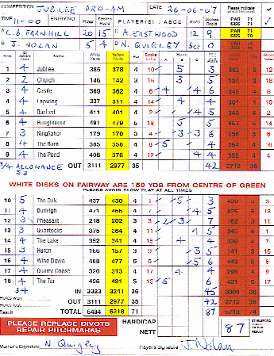

David Weston is the former secretary of Enmore Park GC.

