
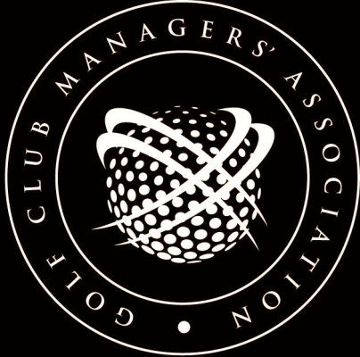
EMPLOYMENT 4009


EXAMPLE ADVERTS – BAR MANAGER (reviewed July 2016)
FAIRACRES GOLF CLUB Limited  require an  EXPERIENCED  Bar Manager  To manage the newly built Clubhouse  Excellent Bar & Catering Facilities  Must be prepared to work long hours  Accommodation provided  The Club is situated near a large town and has an active membership plus a large number of visitors and societies.  Application Form from:  The Secretary/Manager  Fairacres Golf Club Limited, Fairway Drive, Fairacres, XX1 1ZZ.  Closing date for applications 31 August | FAIRACRES GOLF CLUB  Invite applications for the position of:  Clubhouse/Bar Manager  - 18 - hole golf course with 750 members which also offers pay and play facilities  - Excellent earning potential for the successful applicant including annual incentive bonus.  - Accommodation not included.  Apply for application form to:  The Secretary, Fairacres Golf Club Ltd., Fairacres Drive, Fairshire, XX1 1ZZ  Closing date for applications 30 June
FAIRACRES GOLF CLUB  Applications are invited for the position of  SENIOR BAR MANAGER  This is an old established club with many fine traditions.  The current bar manager has been at the club for 35 years and retires in November.  Good size accommodation.  Please apply for application form to:  The Secretary, Fairacres G.C., Fairtower Hill, Fairacres, ZZ1 1YY.  Closing date for applications 30 June | FAIRACRES GOLF CLUB  Fairway, Fairshire, XX1 ZZ1  Require a Bar Manager  18-hole course which has just opened  Currently 9-hole but extending to 18 in 12 months’ time.  Brand new clubhouse with large bar areas.  Experience in licensed trade essential.  Free flat situated in clubhouse.  Apply to: The Manager for Application Form  Closing date for applications 30 June

URGENTLY REQUIRED  EXPERIENCED BAR MANAGER  AND ASSISTANT  This is a very busy club and the successful applicant will have to manage a staff of about 12.  Accommodation is provided by way of a flat in the clubhouse, not suitable for young children or pets.  Excellent salary and working conditions  Apply for Application Form to:  The Hon. Secretary  Fairacres Golf Club,  Fairway Road  Fairway. 1VV 1ZZ  Closing date for applications 31 March | FAIRWAY GOLF CLUB  Applications are invited for  the position of  BAR MANAGER  Must be fully experienced in the licensed trade and prepared to work long hours  Might suit Ex-Publican  Good salary along with a three bedroomed bungalow  Apply for Application Form to:  The Secretary/Manager,  Fairway Golf Club  Fairacres Road, Fairway, 1ZZ 1YY

[This document is prepared for guidance and is accurate at the date of publication only. The GCMA will not accept any liability (in negligence or otherwise) arising from any member or third party acting, or refraining from acting, on the information contained in this document.]

