
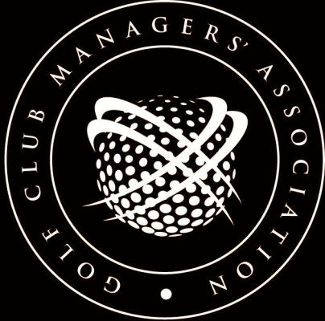
EMPLOYMENT 3023


JOB DESCRIPTION:
BAR MANAGER/SUPERVISOR
(reviewed November 2015)

Job Title
Bar Manager/Supervisor

Main Purpose of Job
To supervise the serving of alcoholic drinks and beverages at the Golf Club.

Job Location
The Clubhouse,.......................................................Golf Club and any other designated area in which the club has a licence to serve drinks.

Responsibilities
To supervise all staff employed by the club for working in the bar area. To see that they conform to current Health & Safety and other relevant legislation. To see that the bar stocks are maintained and that all orders for replacement are ordered through the appropriate source. (All orders are submitted to the club office for ordering by the Secretary/Manager). To see that all cash is handed into the office for safekeeping and that all tills are operating correctly. To make available for monthly stock taking all advice notes, invoices and vouchers, necessary for the stocktaker to perform their task. To keep records of all wastage and stock lost through whatever source. To make sure the bar and serving areas are kept in a clean condition and to supervise the cleaners employed by the club. To set and report any defects in any alarm systems operated by the club.

Duties
Maintain an adequate bar service within the times laid down by the club. See that all staff are properly instructed in their duties. Ensure that all equipment is kept clean and in working order and report to the Secretary/Manager any shortcomings in this direction. Work out the duty bar rosters and see that all staff are aware of them. Collect the weekly staff time sheets and sign them as accurate before handing them over to the club office.

Authority & Discretion
You will have authority to order replacement stock from the club's suppliers as designated by the Secretary/Manager. Staffing levels will be agreed in advance and only changed at the instruction of the Secretary/Manager. The replacement of items such as bar equipment and glasses will normally only be sanctioned by the Secretary/Manager.
Liaison
Apart from liaison with the Secretary/Manager you will be expected to liaise with the club caterer, the social committee chairman and any persons appointed by the committee.

Targets
The Bar Manager will be expected to see that:
- all staff receive the correct training in all aspects of their job.
- all staff conform to the standards of dress set by the club committee.
- all staff give a high standard of proficiency in their dealings with members and guests and that
- any shortcomings are quickly attended to.

Conditions
The Bar Manager will be expected to live in the accommodation provided by the club for which there will be a separate agreement.

[This document is prepared for guidance and is accurate at the date of publication only. The GCMA will not accept any liability (in negligence or otherwise) arising from any member or third party acting, or refraining from acting, on the information contained in this document.]

