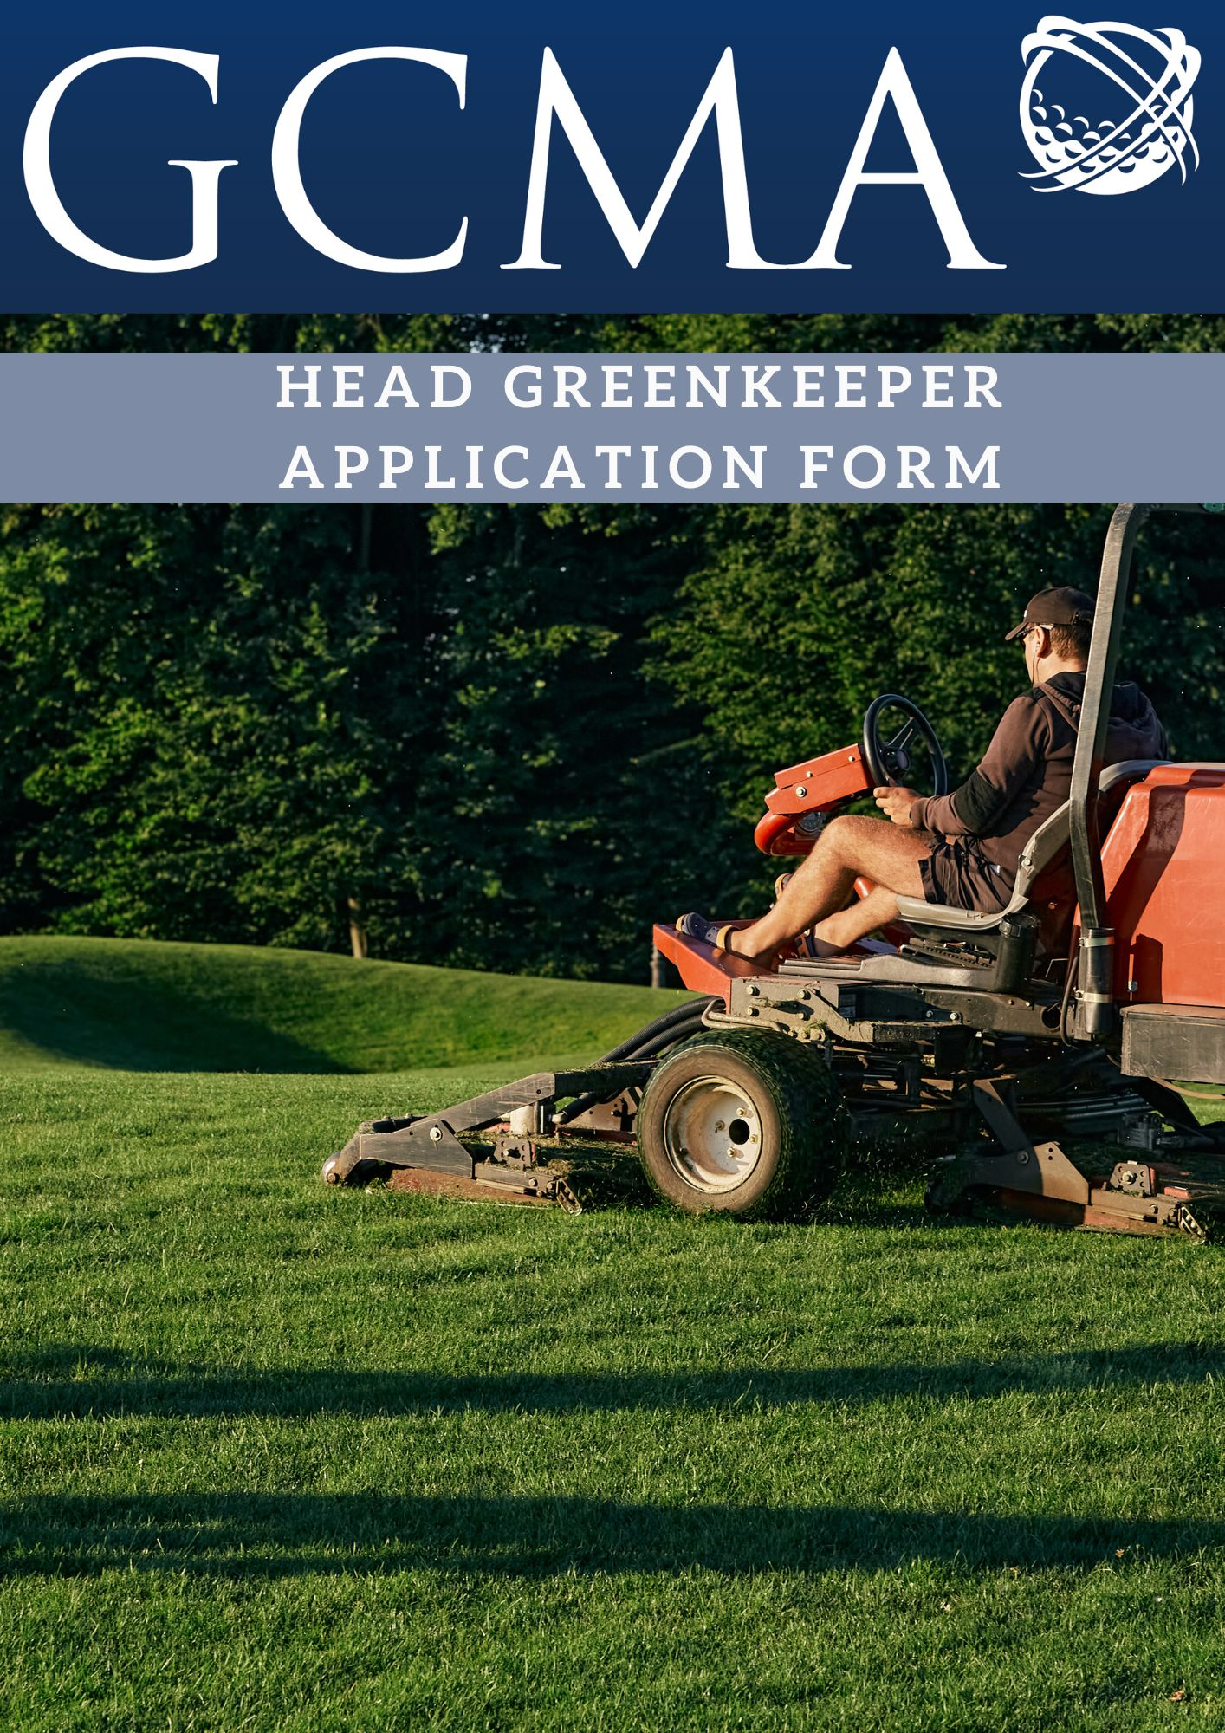

Please answer all questions
Surname
Forename(s)
Address
Postcode
Telephone |  |  | Home:
 |  |  | Mobile:
 |  |  | Work/GC:
E-mail
GOLF CLUB EXPERIENCE – GREENKEEPING
Please state all the clubs you have worked and the position held starting from your
current employment and working backwards
GREENKEEPING QUALIFICATIONS
Please give full details but do not send any original certificates at this stage
GOLFING EXPERIENCE
Please give details of all clubs in which you have been a member of and any country or national honours obtained
Handicap
ADDITIONAL EMPLOYMENT
Please give brief details of other employment you have had since
leaving school - working backwards
Do you hold a current driving license? |  |  |  |  |  |  | Yes |  |  | No
Other qualifications including Education and Further Education
Please give details of two persons who are willing to act as referees on your application.
NB: Contact with them will not be made without your permission
Signature |  |  |  |  |  | Date
How much notice is required in your present position?
Please use extra sheets if there is insufficient space for your answers
Number of extra sheets used

